- Program to display Hello World on the screen using applets

Program:
import java.applet.Applet;
import java.awt.Graphics;

public class FirstApplet extends Applet {
public void paint(Graphics g){
g.drawString("Hello World", 100 ,100);
}
}

/*
<applet code = "FirstApplet.java" width = 500 height = 500> </applet>
*/

Output:
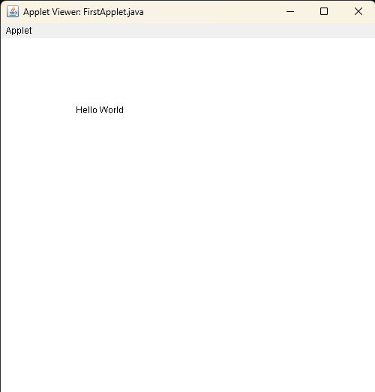

- Program to draw shapes like line, rectangle,ovals using applets.

Program:
import java.applet.Applet;
import java.awt.Graphics;

public class ShapeApplet extends Applet {
public void paint(Graphics g) {
g.drawRect(50, 50, 100, 50);

g.drawLine(50, 150, 150, 150);

g.drawOval(50, 200, 100, 50);
}
}
/*
<applet code="ShapeApplet.class" width = "500" height="300"></applet>
*/

Output:
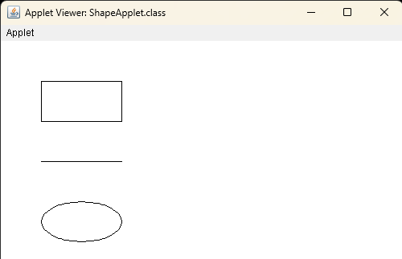

- Program to draw human face using applets

Program:
import java.applet.Applet;
import java.awt.*;

public class FaceApplet extends Applet {
public void paint(Graphics g) {
// Draw face (oval)
g.setColor(new Color(255, 224, 189)); // Skin color
g.fillOval(100, 50, 200, 250);

// Draw eyes (small ovals)
g.setColor(Color.WHITE);
g.fillOval(140, 110, 40, 20); // Left eye
g.fillOval(220, 110, 40, 20); // Right eye

// Draw pupils (small circles)
g.setColor(Color.BLACK);
g.fillOval(155, 115, 15, 15); // Left pupil
g.fillOval(235, 115, 15, 15); // Right pupil

// Draw mouth (arc)
g.setColor(Color.RED);
g.fillArc(150, 200, 100, 50, 0, -180);

// Draw nose (rectangle)
g.setColor(new Color(255, 200, 170));
g.fillRect(190, 150, 20, 50);
}
}
/*
<applet code="FaceApplet.class" width="400" height="400"></applet>
*/

Output:
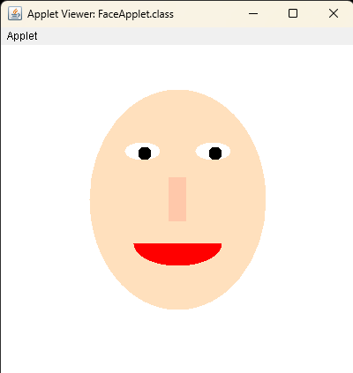
- Program to perform arithmetic operations using AWT.

Program:
import java.applet.Applet;
import java.awt.*;
import java.awt.event.*;

public class ArithmeticApplet extends Applet implements ActionListener {
TextField num1, num2, result;
Button add, subtract, multiply, divide;
Label label1, label2, label3;

public void init() {
// Set layout
setLayout(new FlowLayout());

// Create components
label1 = new Label("Number 1:");
num1 = new TextField(10);
label2 = new Label("Number 2:");
num2 = new TextField(10);
label3 = new Label("Result:");
result = new TextField(10);
result.setEditable(false);

add = new Button("Add");
subtract = new Button("Subtract");
multiply = new Button("Multiply");
divide = new Button("Divide");

// Add components to applet
add(label1);
add(num1);
add(label2);
add(num2);
add(label3);
add(result);
add(add);
add(subtract);
add(multiply);
add(divide);

// Add action listeners
add.addActionListener(this);
subtract.addActionListener(this);
multiply.addActionListener(this);
divide.addActionListener(this);
}

public void actionPerformed(ActionEvent e) {
try {
// Get numbers from text fields
double n1 = Double.parseDouble(num1.getText());
double n2 = Double.parseDouble(num2.getText());
double res = 0;

// Perform operation based on button clicked
if (e.getSource() == add) {
res = n1 + n2;
} else if (e.getSource() == subtract) {
res = n1 - n2;
} else if (e.getSource() == multiply) {
res = n1 * n2;
} else if (e.getSource() == divide) {
if (n2 != 0) {
res = n1 / n2;
} else {
result.setText("Error: Div by 0");
return;
}
}

// Display result
result.setText(String.valueOf(res));
} catch (NumberFormatException ex) {
result.setText("Invalid Input");
}
}
}
/*
<applet code="ArithmeticApplet.class" width="400" height="300"></applet>
*/

Output:

